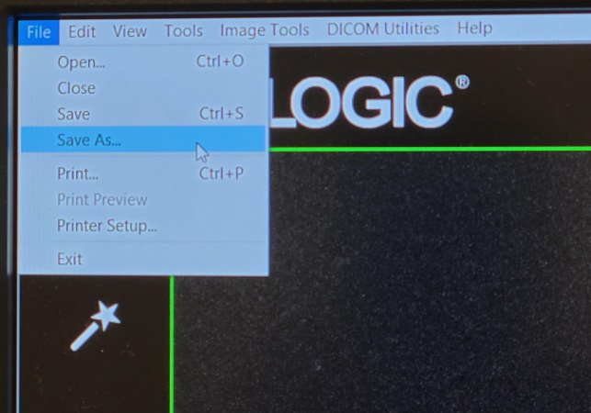
Saving Faxitron Images

Click on the Carrot on the left to display the menu bar along the top of the screen.
Click ‘File’ then ‘Save As’
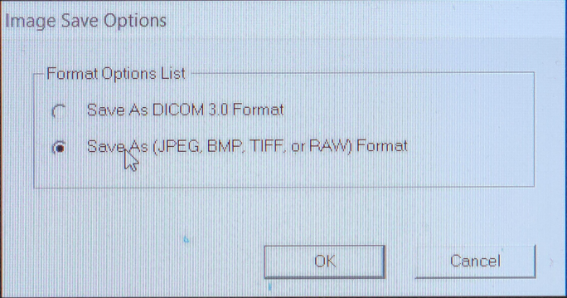

When this appears, click ‘Save As’ and click ‘OK’

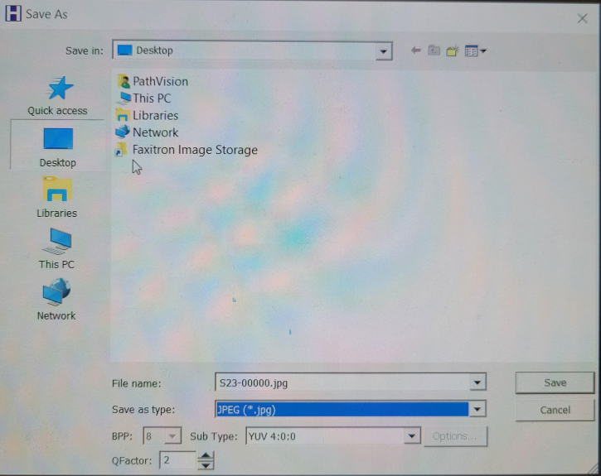

Click either ‘Quick access’ or ‘Desktop’ to find ‘Faxitron Image Storage’ and double click on it.

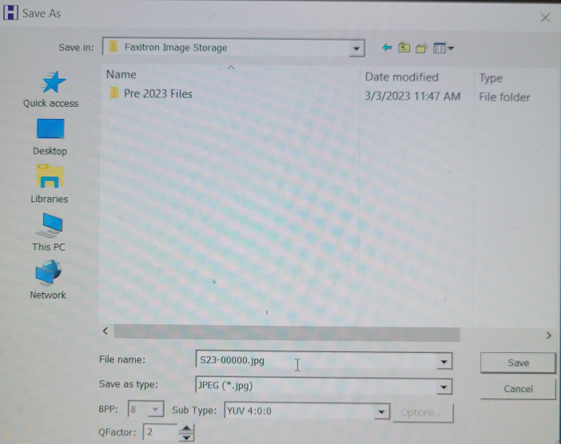

Change ‘File name’ to the case number (S23-0000A) and make sure to include the letter.
Change ‘Save as type:’ to JPEG
Click ‘Save’
These images can be accessed and referenced at your desk under using the following pathway:
Exchange Gross Room Faxitron Image Storage
***IF this doesn’t show up you MUST email Path IT Help Desk***

